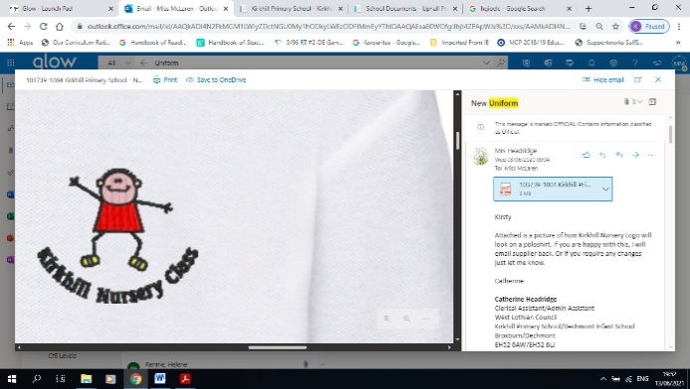

**Kirkhill Primary School and**

**Kirkhill Nursery School**

**Cost of Living Statement**



[](http://www.google.co.uk/imgres?imgurl=http://www.wycombegrange-pru.bucks.sch.uk/images/rrs_logo_std.jpg&imgrefurl=http://www.wycombegrange-pru.bucks.sch.uk/unicef.html&usg=__nm5AKieYGt9EUsdPpcdAguTsQZc=&h=269&w=260&sz=31&hl=en&start=1&zoom=1&tbnid=Ej7-LcBSPK0R7M:&tbnh=113&tbnw=109&ei=KtIrT6SsDYTc8QOwhZmKDw&prev=/search%3Fq%3Dunicef%2Brights%2Brespecting%2Bschool%2Blogo%26um%3D1%26hl%3Den%26safe%3Dactive%26sa%3DN%26gbv%3D2%26tbm%3Disch&um=1&itbs=1)All of our staff are aware of the effects of poverty and how it pertains to the context of our school, community and children.

**Rights of the Child**

We are committed to the UNCRC Rights of the Child and adhere to the articles to ensure the rights for every child are adhered to, whilst ensuring equity for all.

**Getting Dressed for School**



Universal:

School uniform is a white polo shirt and school jumper and un-embroidered items are acceptable. Our ELC setting provides all children with a school tie. Any shorts and T shirt are acceptable for PE with the exception of football strips.

Targeted:

We currently have a school uniform bank situated at the office. We have access to other school uniform banks and have accessed this service for families. We also have nearly new uniforms available and willingly accept donations.



**Travelling to School**

Universal:

Our school serves the catchment of Broxburn and almost all children live within walking distance to school. Buses are provided for those travelling from Dechmont. After school clubs are run in school where there is no need to travel any distance. All families have the information in order to apply for free bus travel and can ask for assistance from school.

Targeted:

School Staff can support those requiring assistance to complete transport applications.



**Friendships at school**

Universal

Uniform is promoted to negate any peer pressure for branded and fashion clothing. While there is a device policy in school all pupils have access to digital technology in school. Our Health and Wellbeing curriculum has been refreshed to support emotional and social wellbeing.

Targeted:

We provide Nurture support for social skill development. We provide Life Skills Groups to support our learners to be successful throughout their lives.



**Learning at school**

Universal:

Stationary is provided for all classes to access at all times. There are options for resources to be borrowed to support learning i.e. devices, dictionaries, rulers, calculators. Digital technologies are supplied for those requiring support to any online materials. Snack is available for all.

Targeted:

Reviews are held regularly to provide bespoke learning targets for those children who need support with their learning. This is continually monitored. We work with multi-agencies in order to ensure appropriate support is provided where required.



**School trips**

Universal:

We usually plan school trips in advance to ensure parents/carers are notified in a timely manner. Class trips are usually limited to one annually to reduce the cost. We usually try to source locations that provide free transport to reduce the cost of trips per person. Due to the rising costs, learners can participate in an activity week and/or a residential. All trips and activities be paid up through a payment card.

Targeted:

School Staff are able to support families and sign post them for financial help if and when required.



**Fun events**

Universal and targeted:

Fun events in school including parties are paid for by the Parent Council and through school fund. We always ask for donations rather than a contribution to dress down days and fund raisers.

**Eating at school**

Universal

Parents/carers can call the school office or visit the council website to apply for Free School Meals. Cashless catering means that there is less stigma attached to pupils eligible for free school meals.

The school operates a free breakfast club for all pupils. We also have a free snack box in each classroom for all pupils who do not have a mid-morning snack.

<https://www.westlothian.gov.uk/mealsandclothing>

Targeted:

For those children who have not had breakfast Support Staff operate a drop in breakfast provision in the dinner hall.



**Attitudes towards poverty**

Universal:

Staff have a good awareness and knowledge and understanding of the children and families in our school. Our curriculum is due to be refreshed to allow us the opportunity to explore the issues surrounding poverty and we will begin to deliver our Participatory Budgeting Model to support this. All pupils are part of Ambassador Groups where they discuss and take action on certain topics including after schools clubs, rights respecting and Eco.

Targeted:

Our staff offer regular drop in sessions and speak with individual families in regards to supporting and sign posting to help available. We have positive multi-agency working, which offers positive support for those that require individualised input.



**School clubs**

Universal:

All in school led/organised after school clubs are run currently funded through PEF where appropriate to ensure these can be accessed by all of our children. We work closely with our community partners to support access to after school clubs.

Targeted:

Our staff team sign post and encourage families to attend in school clubs and activities.

**Home learning**

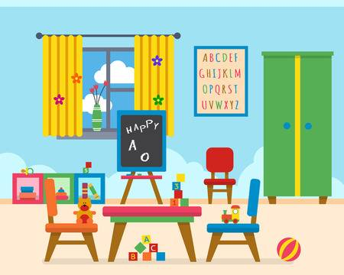

Universal:

Children will have access to digital technologies to support engagement with learning at home. Our school will ensure all have access to equipment, resources and supports to support engagement in home learning activities.

Targeted:

Our staff run homework support sessions to offer help/advice and support when required. Laptops and Devices lending library taking into account those with larger families.

**Additional Supports**

Universal:

We link with the adult learning team to offer parents/carers additional learning opportunities and qualifications.

Targeted:

The advice shop holds meetings for parents/carers to review their benefits and to receive further support in budgeting.

**Further Support**

Our staff are committed in helping reduce the cost of the school day and to narrow the poverty related attainment gap.

For further support with the cost of the school day, you could contact Mrs Lynne McDonnell on 01506 280920 or email the school office.

More information for support from West Lothian Council, can be found here: <https://www.westlothian.gov.uk/helpwithcosts>